DES-030 Deployment Instruction
Barnes Project
Initial Load of Products and Pricebook to Salesforce
Document Properties
Author | Jennilyn Romero
Creation Date | 25/10/2024
Last Updated | 05/11/2024
Document Reference | TAR-040-M3 Initial Load of Products and Pricebook to Salesforce(PARTCOPY) - Technical Specification 1.0.docx
Version | 1.0

Approvals | Position
<Approver 1>
<Approver 2>

Document Control

Change Record
1
Date | Author | Version | Change Reference
29/10/2024 | Jennilyn Romero | 1.0 | Initial version

Reviewers

Name | Position

Contents
1 Document Control 2
1.1 Change Record 2
1.2 Reviewers 2
2 Introduction 4
2.1 Purpose of this Document 4
3 Installation 5
3.1 Deliverable locations 5
3.2 Deliverables and Dependencies 5
3.3 Installation Instructions 7
4 Recovery Strategy 11
4.1 Recovery Instructions 11

Introduction

Purpose of this Document
This document identifies the information necessary to promote Initial Load of Products and Pricebook to Salesforce components to PRD environment.
- MEC map
- ION Components
  - Document Flow
  - API Connection Point
  - XSLT Mapping
  - ION API Suite

Installation
General Information
Central Authentication | <How the users sign in>
Hardware Anomalies | <Cluster, Storage Area Network, other>
Security
Other

Deliverable locations
General Information Workflow
Environment to where the promotion will be done | TST / PRD

Deliverables and Dependencies

DEVELOPED EXTENSIONS
Object name | Type | New/  Modified
M3BOD_ItemMaster_Sync_Out_2_14_6_Custom.zap | MEC mapping | New
M3-Salesforce_ItemMaster_InitialLoad_Products_<SalesforceEnvironment>.zip | Document Flow | New
SFDC-ItemCreateProduct_<SalesforceEnvironment>.xml | API Connection Point
SFDC-ItemUpdateProduct_<SalesforceEnvironment>.xml | API Connection Point
M3-Salesforce_ItemMaster_InitialLoad_StandardPriceBooks_<SalesforceEnvironment>.xml | Document Flow
SFDC-ItemCreateStandardPB_<SalesforceEnvironment>.xml | API Connection Point
SFDC-ItemUpdateStandardPB_<SalesforceEnvironment>.xml | API Connection Point
M3-Salesforce_ItemMaster_InitialLoad_MaumeePriceBooks_<SalesforceEnvironment>.xml | Document Flow
SFDC-ItemCreateMaumee_<SalesforceEnvironment>.xml | API Connection Point
SFDC-ItemUpdateMaumee_<SalesforceEnvironment>.xml | API Connection Point
SyncItem_To_SFDC_SyncItem.xml | XSLT Mapping | New
Remove_Namespace_XSLT_ItemMaster.xml | XSLT Mapping | New
XSLT_StatusConvert_SFDC.xml | XSLT Mapping | New

<SalesforceEnvironment> - Salesforce Environment
PC – Part Copy
FMC – Dev FMC
PRD - PRD

PREREQUISITES AND DEPENDENCIES
The integration to salesforce has to be setup in the ION API Suite > Authorized Apps.
Refer to M3 integration for Salesforce CRM.pdf (Page 13-17,40-48)

Installation Instructions

MEC
Important Step:
- Deactivate standard BOD Agreement in EC Admin > Server > Agreement Status

- Once Standard BOD Agreement is deactivate, proceed with MEC map deployment

- In the MEC Mapper tool, import the mec map (.zap file).
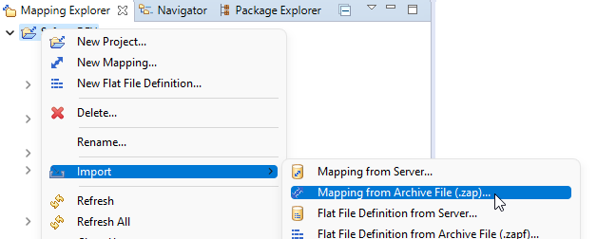
- Right-click Publish for the imported map.
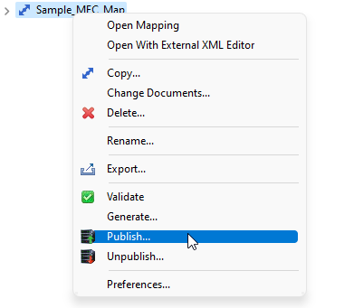

- Select the server to publish the MEC map.
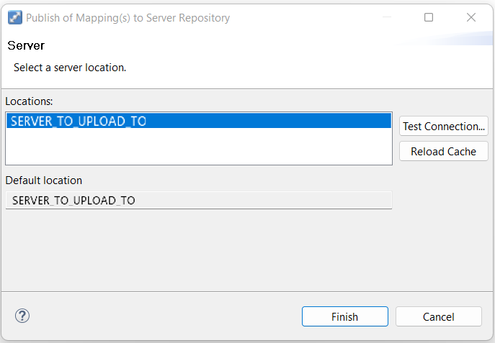
- Continue login to tenant to publish the MEC map.
- Activate the Custom agreement in Enterprise Collaborator Admin:
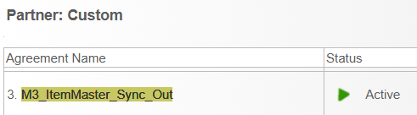

ION COMPONENTS

XSLT MAPPING
- Navigate to ION Desk then go to Connect > Mappings.
- On the top pane, select the Import button.
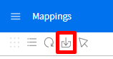
- Import the following ION mapping:
SyncItem_To_SFDC_SyncItem.xml
Remove_Namespace_XSLT_ItemMaster.xml
XSLT_StatusConvert_SFDC.xml

- Activate the mapping.

API CONNECTION POINT
- Navigate to ION Desk then go to Connect > Connection Points.
- On the top pane, select the Import button.

- Import the following ION mapping:
SFDC-ItemCreateProduct_<SalesforceEnvironment>.xml
SFDC-ItemUpdateProduct_<SalesforceEnvironment>.xml
SFDC-ItemCreateStandardPB_<SalesforceEnvironment>.xml
SFDC-ItemUpdateStandardPB_<SalesforceEnvironment>.xml
SFDC-ItemCreateMaumee_<SalesforceEnvironment>.xml
SFDC-ItemUpdateMaumee_<SalesforceEnvironment>.xml

- Activate the connection points when needed.

DOCUMENT FLOW
- Navigate to ION Desk then go to Connect > Data Flows.
- On the top pane, select Import button.

- Ensure that the following document flows below appears in the list.
M3-Salesforce_ItemMaster_InitialLoad_Products_<SalesforceEnvironment>.zip
M3-Salesforce_ItemMaster_InitialLoad_StandardPriceBooks_<SalesforceEnvironment>.xml
M3-Salesforce_ItemMaster_InitialLoad_MaumeePriceBooks_<SalesforceEnvironment>.xml

- Save and Activate/Reactivate the Data Flow when needed for the initial loaded process.
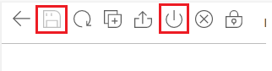

Manual Configuration

Updating record type id
Record type ID may vary per Salesforce environment.
Currently the value is hardcoded in each connection point, the following connection points must be updated based on the Environment Record Type ID :
Initial Load Connection Points
- SFDC-ItemCreateProduct_<SalesforceEnvironment>
- SFDC-ItemUpdateProduct_<SalesforceEnvironment>
Steps:
- Navigate to ION Desk then go to Connect > Connection Points.
- Open the Connection points to be updated.
- Click Documents tab then the ION API(ex. ItemCreate)
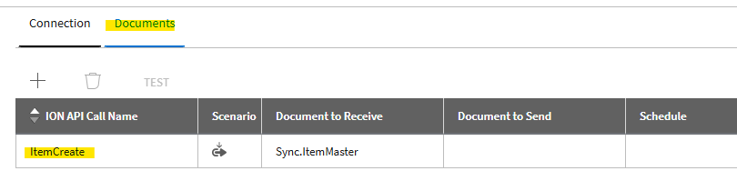
- On the Request Body tab, copy the contens of Body.
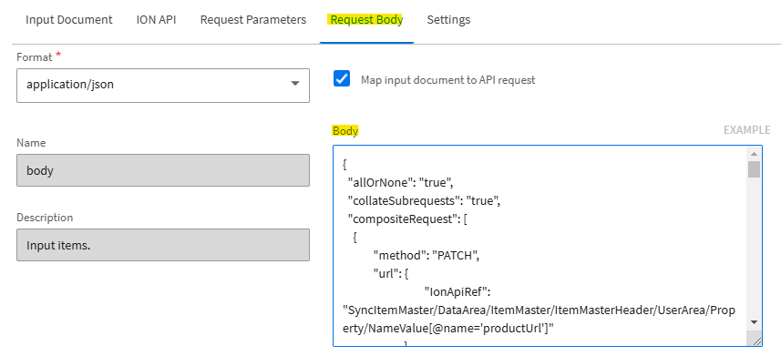

- Update the RecordTypeID(line 47) based on the environment value.
The value must come from Salesforce.
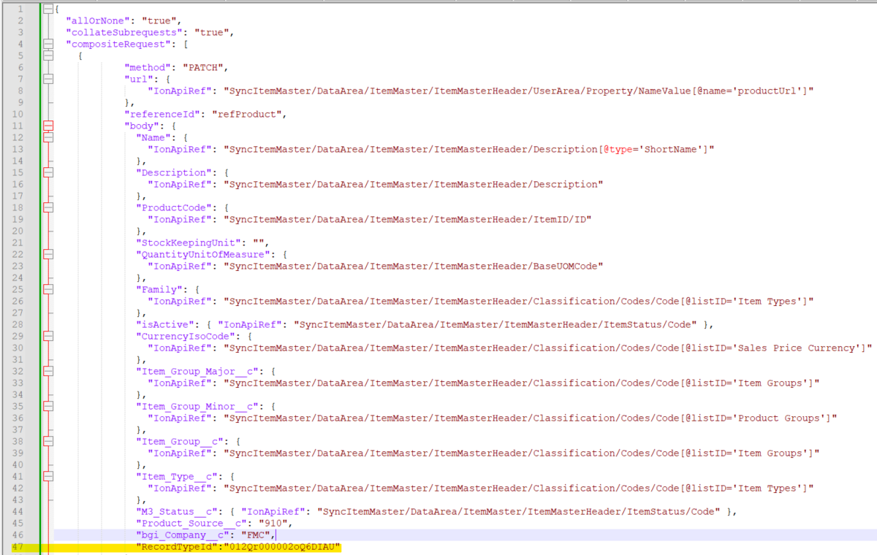
- Repeat steps 2-5 for all connection points:
Initial Load Connection Points
- SFDC-ItemCreateProduct_<SalesforceEnvironment>
- SFDC-ItemUpdateProduct_<SalesforceEnvironment>

- Once all connection points are updated, save the connection Points.
- Reactivate the document flow based on the process needed .
- M3-Salesforce_ItemMaster_InitialLoad_Products_PC (Initial Load)

Recovery Strategy
General Information
Central Authentication | <How the users sign in>
Hardware Anomalies | <Cluster, Storage Area Network, other>
Security
Other

Recovery Instructions
If removal needs to be done:
- Navigate to ION Desk > Connect > Data Flows
- Search for xxxxx and click on the deactivate button.

